**Supplementary Materials for**

**Critical Role of La doping for Topological Hall Effect**

**in Epitaxial EuO Films**

Yu Yun1,2†, Yang Ma1,2†, Tang Su1,2, Wenyu Xing1,2, Yangyang Chen1,2, Yunyan Yao1,2, Ranran Cai1,2, Wei Yuan1,2, and Wei Han1,2*

1 International Center for Quantum Materials, School of Physics, Peking University, Beijing 100871, P. R. China

2 Collaborative Innovation Center of Quantum Matter, Beijing 100871, P. R. China

† These authors contributed equally to the work

* Correspondence to: weihan@pku.edu.cn

**Figure S1**

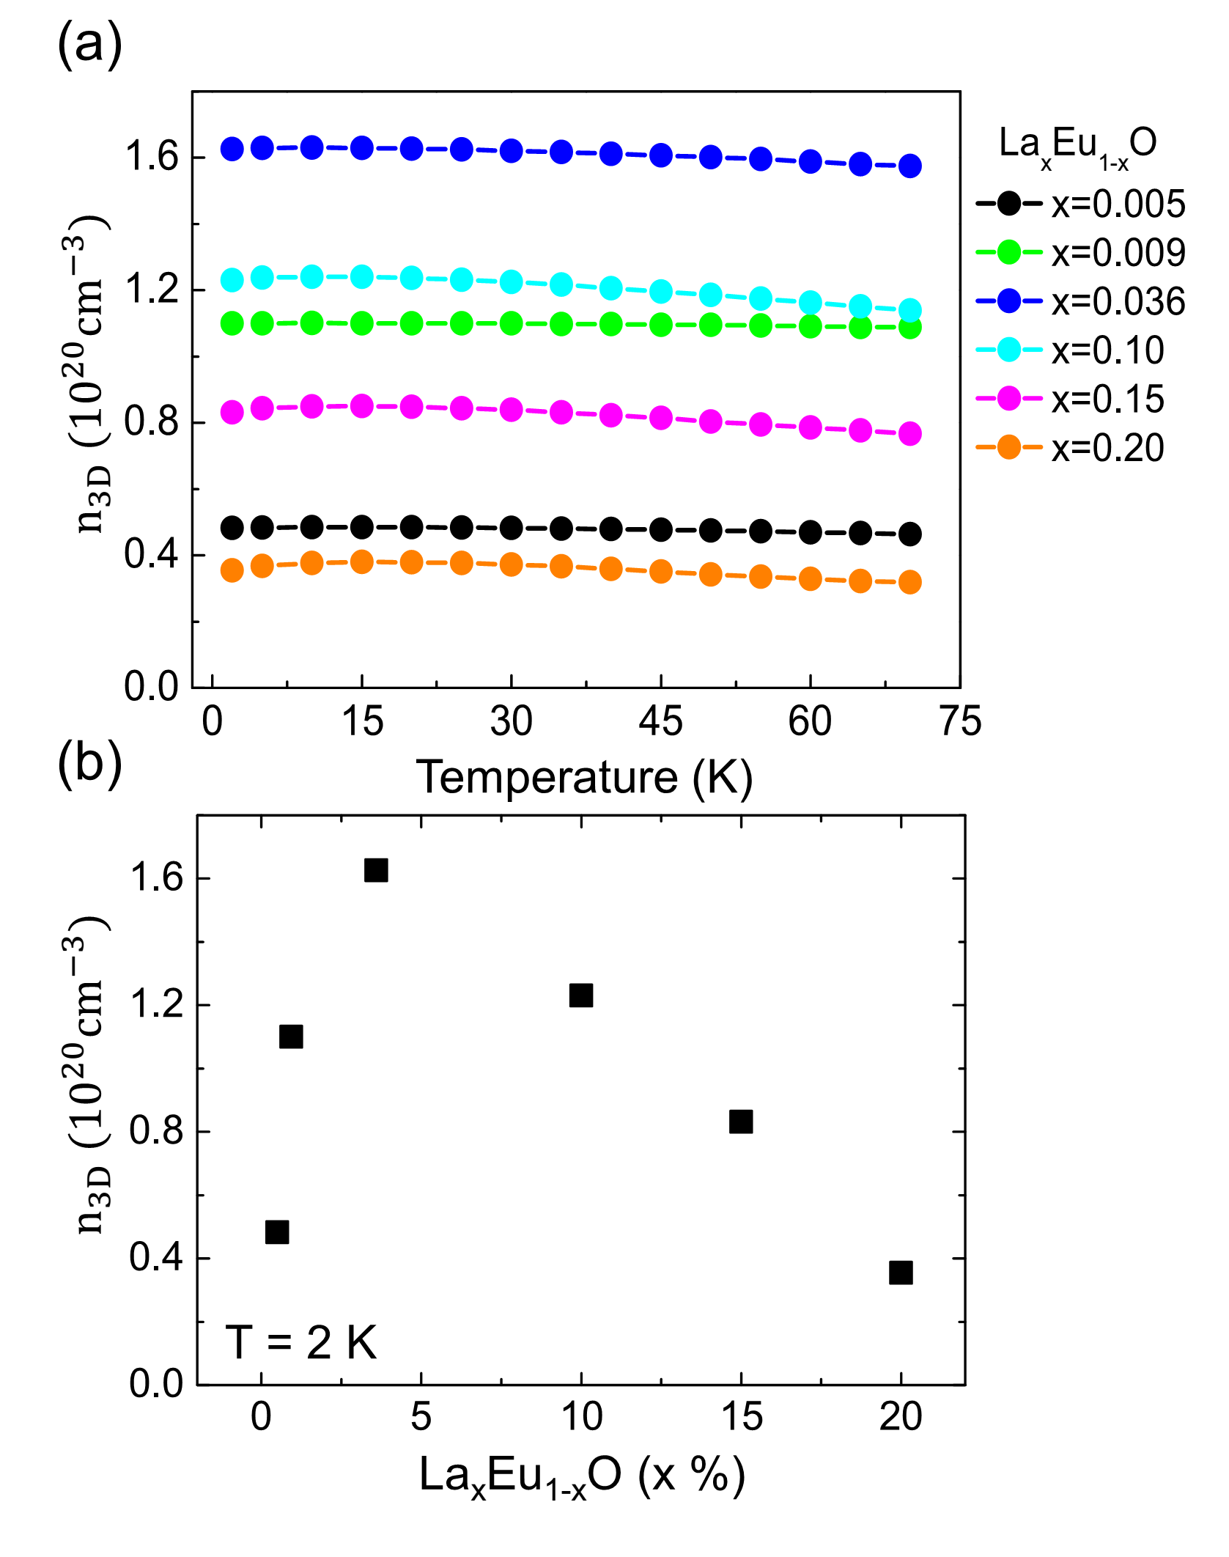

FIG. S1. Temperature dependence and doping dependence of the carrier density for LaxEu1-xO. (a) The carrier density as a function of temperature for LaxEu1-xO thin films, from x=0.005 to x=0.20. (b) The carrier density at 2K as a function of La doping.

**Figure S2**

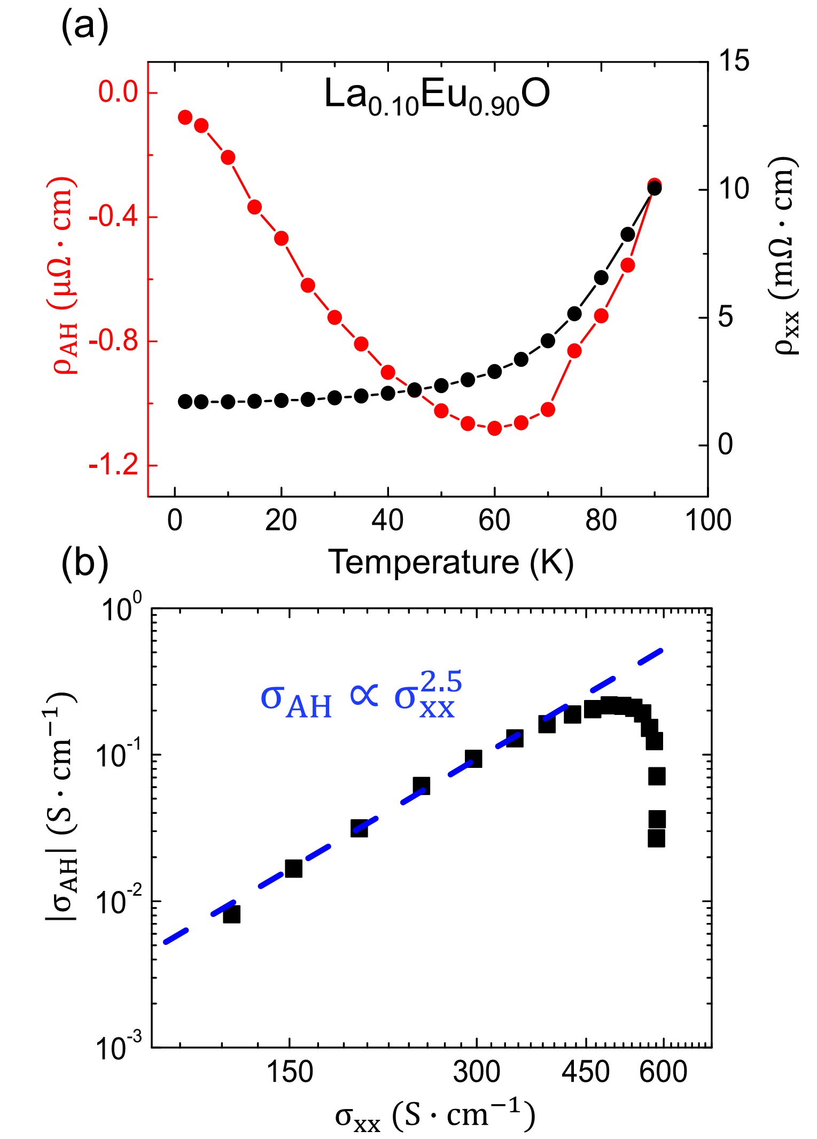

FIG. S2. AHE analysis for La0.1Eu0.9O film. (a) Anomalous Hall resistivity and longitudinal resistivity as a function of temperature. (b) AHE scaling formula. The blue dashed line indicates the fitting result, giving the parameter 2.5.

**Figure S3**

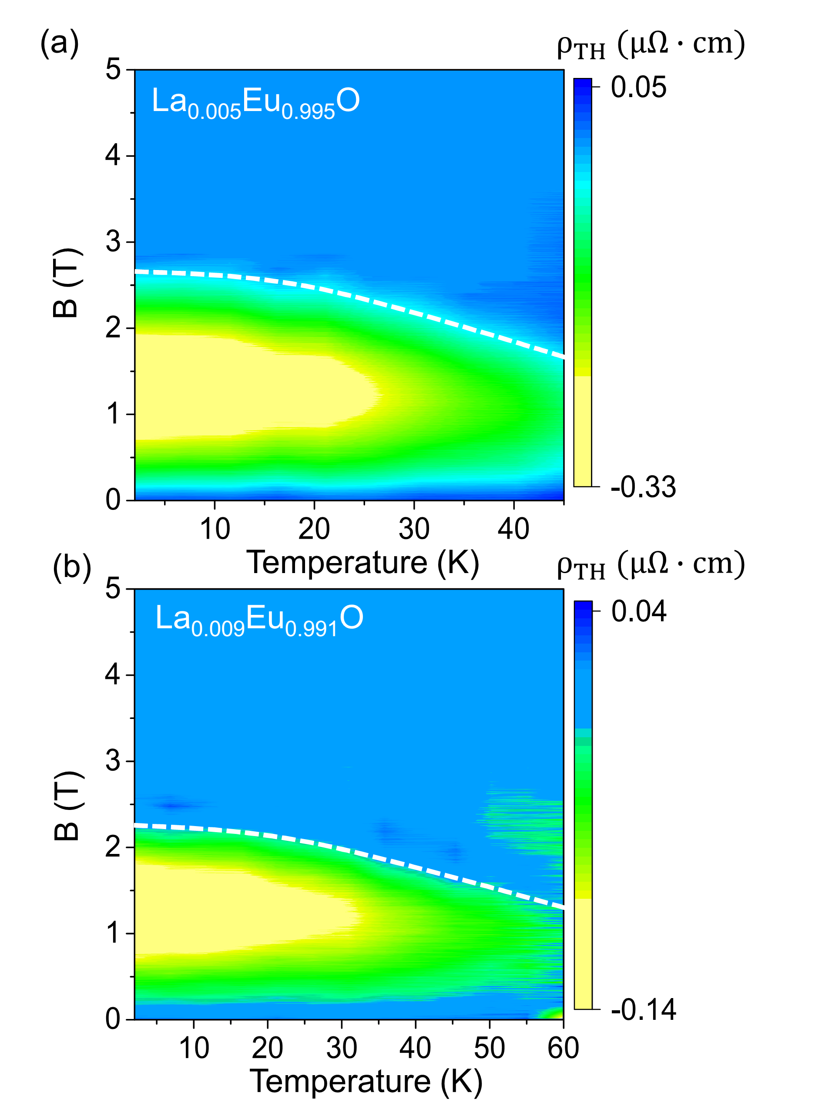

FIG. S3. THE phase diagram for low doping films. (a-b) THE phase diagram for x=0.005, 0.009 LaxEu1-xO thin films. The white dashed lines are guide to the saturation magnetic field.

**Figure S4**

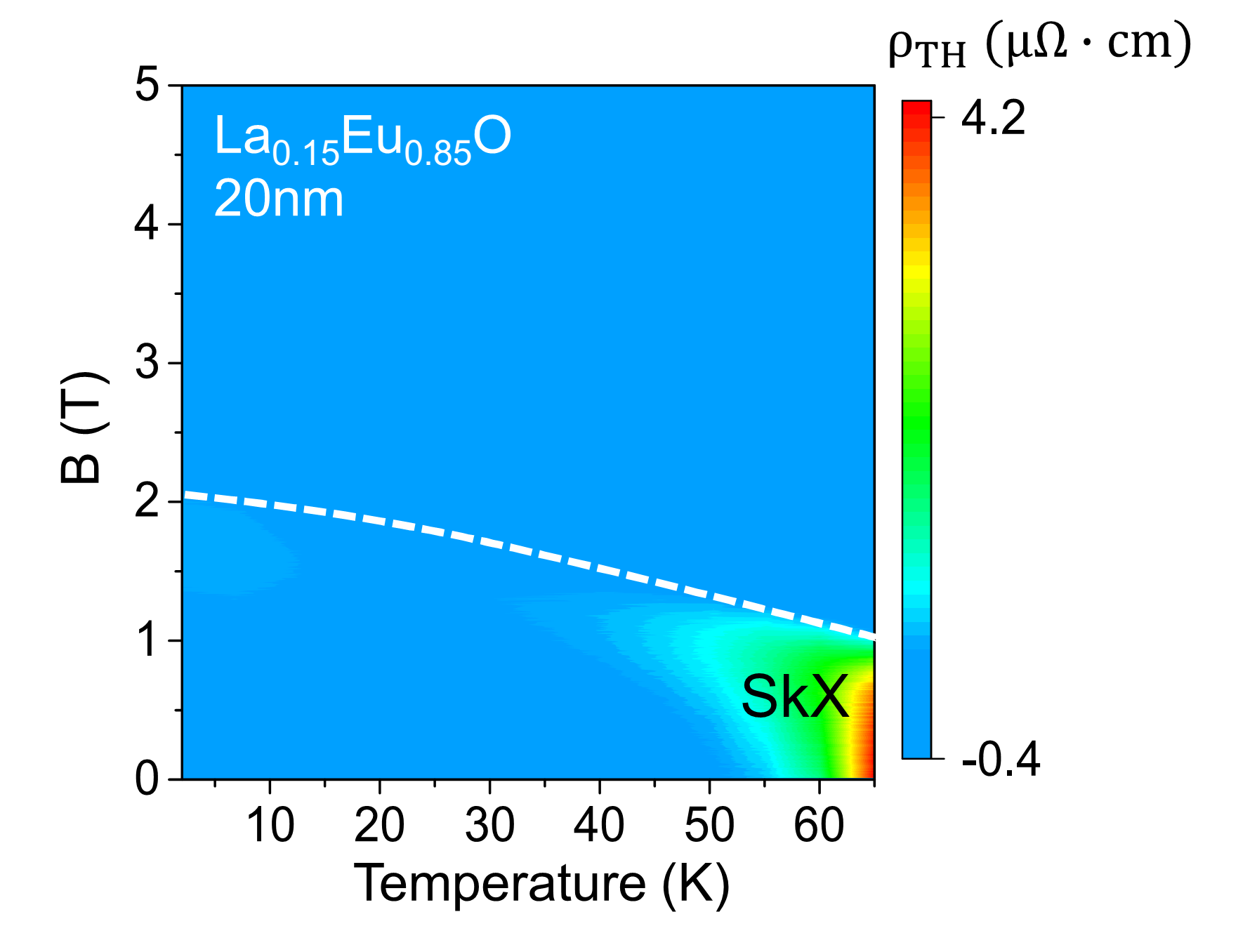

FIG. S4. THE phase diagram for the thinner film. THE phase diagram for La0.15Eu0.85O thin films. The suppressed Skyrmions phase are consistent with [M.kawasaki PRB **91**, 245115 (2015) ]